Part 7 Designing Message Interface

* So now in this we will be creating the chat box area
* 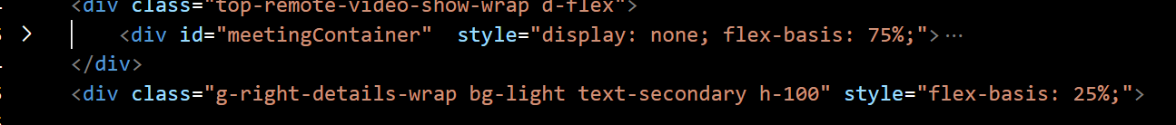
* 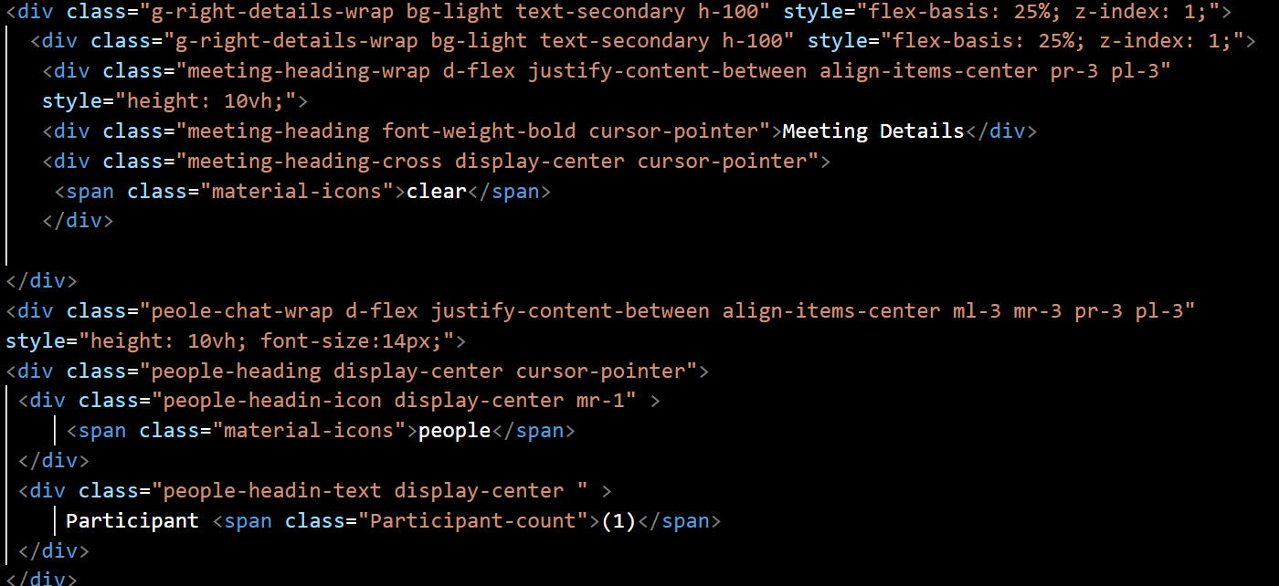

PART2 :Creating a JavaScript

* Now we will be writing JavaScript code
* 
* 